Statistics

1. Data types in statistics
2. Categorical and Numerical
3. Levels of data

* Nominal level
* Ordinal level
* Interval level
* Ratio level

1. Population
2. Sample
3. Population vs Sample
4. Inferential statistics
5. Frequency table: class vs frequency
6. Relative frequency table
7. Bar chart
8. Pie chart
9. Frequency distributed table: CI vs Interval freq
10. Histogram
11. Distribution graph
12. Central tendency
13. Mean- Median-mode
14. Mean vs Median
15. Outliers
16. Skewed data
17. Pos – Neg – normal
18. Bi mode – Uni mode – Multi mode
19. Data dispersion
20. Range : It will not consider middle value
21. Mean deviation: ; Total deviation =0
22. AMD: : graph is dis cont at point zero
23. Variance : value will be raise as well as units also
24. Standard deviation
25. Variance : how a data is varying it self
26. Covariance: how a data is varying w.r.t other variable
27. Pos or neg or neutral
28. Covariance Matrix
29. Pearson Correlation ( r ) -1 to 1 : cov(x,y)/std(x) * std(y)
30. Percentile
31. Quartile
32. Outliers analysis
33. Box plot
34. How to Deal the outliers

* Drop if outliers <2%
* Fill with Median value
* Cap the values with Q3 and Q1

1. Normal distribution points
2. Emperical rule 68-95-99.7
3. Chebyshev inequality ( if data does not follows normal distribution ) (1-1/k^2)

$$Standardization of data:$$

|  |  |  |  |
| --- | --- | --- | --- |
| Age | Income | Spending percentage | Credit usage points |
| 30 | 100000 | 30 | 40 |
| 31 | 500000 | 55 | 140 |
| 32 | 1000000 | 75 | 250 |

The number of columns : 4 it is a 4 dimensions of data

First observation: (30,100000,30,40)

Every population of data has different range of values and different units

It is very very important to **make all the data points under one scale**

1. Z-standardization ( Z-score)
2. Normalization

$$Z-score or Z-standardization:$$

$$u-1σ to u+1σ=68\% of data will cover$$

$$u-2σ to u+2σ=95 \% of data will cover$$

$$u-3σ to u+3σ=99.7\% of data will cove$$

$$u+1σ=x$$

$$u+1σ=x$$

$$1σ=x-u$$

$+/ 1=\frac{x-u}{σ}$ $$+/ 2=\frac{x-u}{σ}$$

$$+/ 3=\frac{x-u}{σ}$$

$$z=\frac{x-u}{σ}$$

$$x is a original data points -\inf{ to inf}$$

$$on this x data points we calculate mean , std we calculted a new data$$

$$z is a new line -3 to 3$$

|  |  |  |  |
| --- | --- | --- | --- |
| Age | Income | Spending percentage | Credit usage points |
| 30 | 100000 | 30 | 40 |
| 31 | 500000 | 55 | 140 |
| 32 | 1000000 | 75 | 250 |

30 31 32 what is the mean = 31

Std = 30-31= -1 ==== > 1

31-31 =0 ==== > 0

32-31=1 ====== > 1

1+0+1 = 2/3= 0.66 = root (0.66)

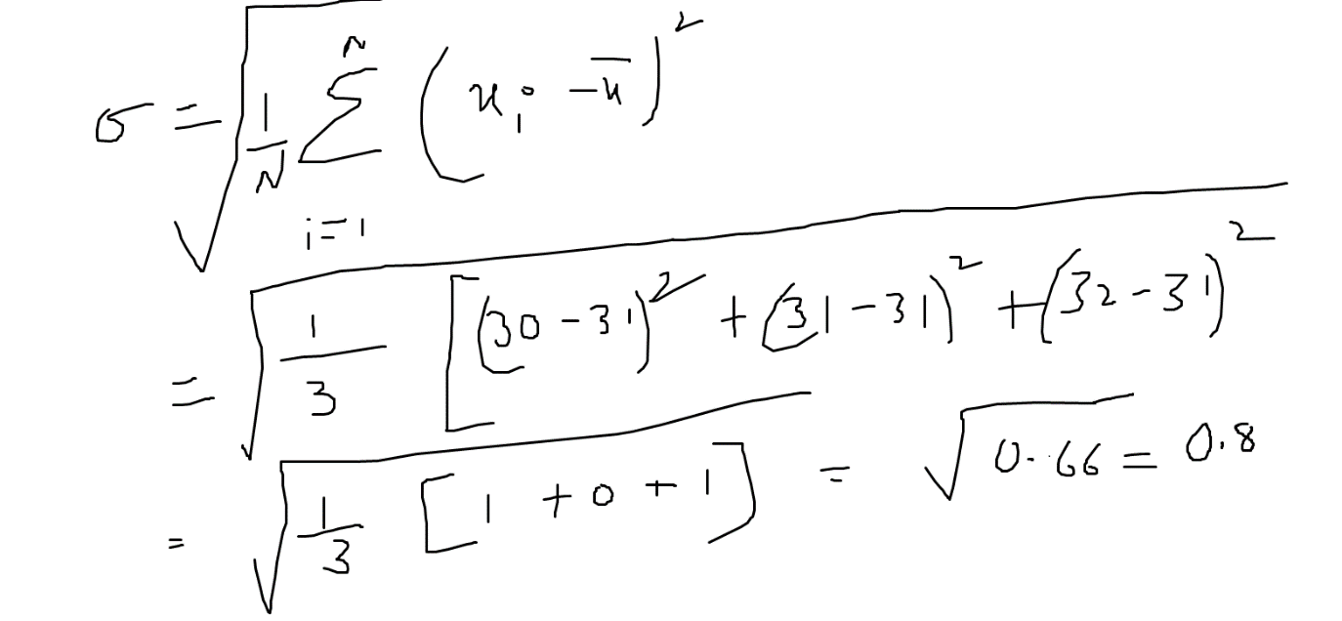

|  |  |
| --- | --- |
| Age (x)a | Age (Z) = (x-u)/sigma |
| 30 | (30-31)/0.8= -1/0.8= -10/8= -1.25 |
| 31 | 31-31/0.8=0 |
| 32 | 32-31/0.8=1.25 |

Distance metrics 30,100000 31,500000

-1.25 to 2

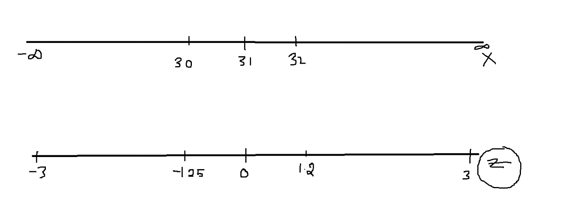

$$Z-score :$$

$$It is the one of the tech to make all the data points under one scale$$

$$the scale ranges -3 to 3$$

$mean=0, stnadrd deviation≅1$

$$Z\left(u,σ\right)=\frac{x-u}{σ}$$

$${f\left(u,σ\right)=\frac{1}{k}*e}^{-\frac{z^{2}}{2}}$$

Now thinking how python will use this formulae’s : Packages

LR ML : 1 week 1min

standardization and z score both are same

sir how to decide which one we will use , normalization or z score

don't we need to verify whether the data follows normal distribution

Read about Normal scale and Log scale

Normal scale and Z-scale

Machine Learning algorithms find the relation between then

Cov(age,Income) = age 30 31 32 income 1lak 5 lak 10lak (100000-30)^2

$$Normalization: 0 to 1$$

|  |  |
| --- | --- |
| Age X | Age normalization |
| 30 | 30-30 ====0 |
| 31 |  |
| 32 | 32-30/32-30=1 |

$$Real line the scale ranges -inf to inf$$

$$Z-score the scale ranges -3 to 3 : Classification problems$$

$$what is Influential outlier:$$

$$if any data point is outlier in real line as well as in z-line it is called influential outlier$$

$$Normalization the scale ranges 0 to 1 :$$

$$Deep learning Images$$

$color imge : pixel values ranges from 0 \left(Black\right) to 255\left(white\right)$

$$and Gray 0 (Black) to 1(white)$$

$$ML divided into Supervised \left(target is there\right)and Unsupervised(No target)$$

$$if Target column numerical : Regression problem$$

$$Step-1: Import required packages$$

$$Step-2:We read the data$$

$$Step-3:We do some quick checks$$

$data read properly$

$number of observations$

$number of columns$

$the shape of the data$

$type of columns$

$$Step-4:If data has any missing values : will fill the missing values$$

$$Step-5:Categorical data analysis \left(Uni variate analysis\right)$$

$Will try undersand how many labels are there in that particular column$

$will try to create frequency table$

$bar chart$

$Relative frequency table$

$pie chart$

$$Step-6:Numerical data analysis \left(Uni variate analysis\right)$$

$Will try get all the statistical value mean median 25p 50p 75p$

$will plot the histogram$

$will plot the distribution plot$

$Idea of outliers$

$box plot$

$$Step-7: will start with outlier analysis$$

$how many outliers are there$

$how to fill that outliers$

$box plot to check$

$$Step-8: Bi variate analysis$$

$Categorical vs Categorical$

$Categorical vs Numerical$

$Numerical vs Numerical$

$Tabular analysis and Graphical analysis$

$$Step-9: Data transformations \left( Python\right)$$

$after remove outliers if data skewed will convert into normal$

$$Step-10: Correlation of Numerical columns$$

$$Step-11: If it is necessary will standadrdize or normlaize only on numerical columns$$

$$Step-12: will convert categorical data to numerical data (Python)$$

$We can map by our own yes=1 No=0$

$one hot encoder$

$Lable encoder$

$$Step-13: Your data is now numerical format,$$

$$preprocessed way it is reday apply on any ML model$$

$$Step-14 \left(trail \right):If you see more dimnsions, will try to reduce number of columns$$

$which means we not remove the columns : Principle Component Analysis$